A1376-Eur-England-Kent-Rickson’s Pit-Acheulian-Hand Axe-ca 250,000 BP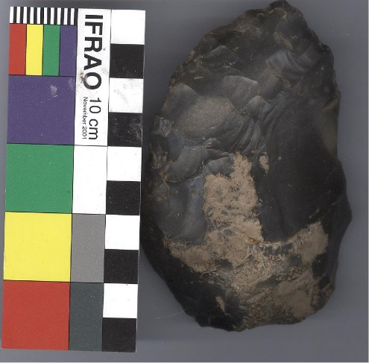

Fig. 1. England-Kent-Rickson’s Pit-Acheulian-Hand Axe-ca 250,000 BP

**Formal Label:** England-Kent-Rickson’s Pit-Acheulian-Hand Axe-ca 250,000 BP

**Display Description:**

**Accession Number:** A

**LC Classification: Date or Time Horizon:** ca 250,000 BP

**Geographical Area:** England-Kent-Swanscombe, Rickson’s Pit

**Map, GPS coordinates:**

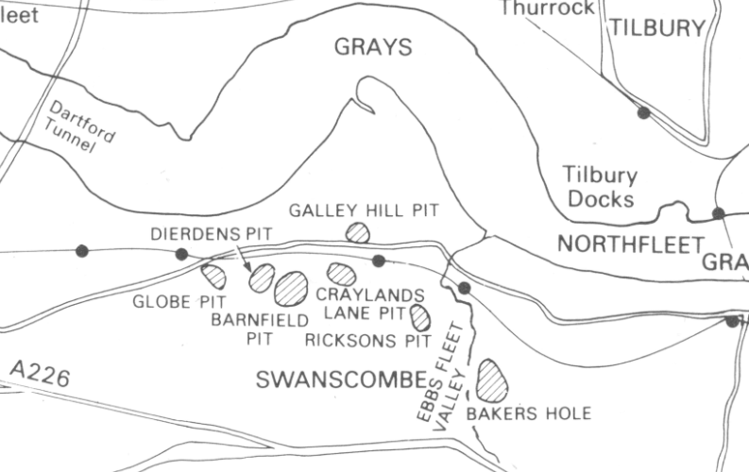

**Cultural Affiliation:** Acheulian

**Medium:** Le Grand Pressigny flint

**Dimensions:**

**Weight:**

**Condition: This** Acheulian **hand axe** has a patina and soil sheen on the original surfaces with no modern damage or repair.

**Provenance:** This is from an old English collection of Swanscombe-Northfleet area artifacts.

**Discussion:**

This Acheulian hand axe from Rickson’s Pit, was made from black flint by *Homo erectus* in the Acheulian method from a flake, the predominant tool technology of the Lower Paleolithic, ca. 250,000 years ago. Its patina and soil sheen on original surfaces were accumulated by its use in hunting and butchering large Pleistocene mammals and its subsequent burial for over at least 250 millennia. The edges show extensive retouching to make it very sharp on the cutting edges to cut through tough hides, since the hunter’s life depended on it.

The Acheulian Tradition first began in Africa and there it is well-defined and most diverse when compared to other regions where it eventually diffused.  Acheulian tools are fashioned from large flakes as opposed to using a whole cobblestone as the core.

The first hominins to live outside of Africa were *Homo erectus*.  Around 1.8 million years BP, these hominins spread from Africa to south Asia keeping to the tropical zones which they preferred.  By 700,000 years BP they had colonized temperate regions of Europe and North China, but they never reached Australia or the Americas.  Unlike *Homo Neanderthalensis*, *Homo erectus* avoided glacial and sub-Artic regions.  *Homo erectus* arrived in England when stone tool technology included both Acheulian flake tools and the earlier Oldowan style pebble tools.  Between 700,000 and 400,000 BP, the first hand-axes were made by *Homo erectus* in England, sometimes called the Clactonian industry.  Both occupied sites and kill sites indicate that large game animals were butchered simultaneously with stone tool manufacture.